**Jasper Reports – How to connect a data source DBMS & CSV**

How to create a Jasper Report in eclipse

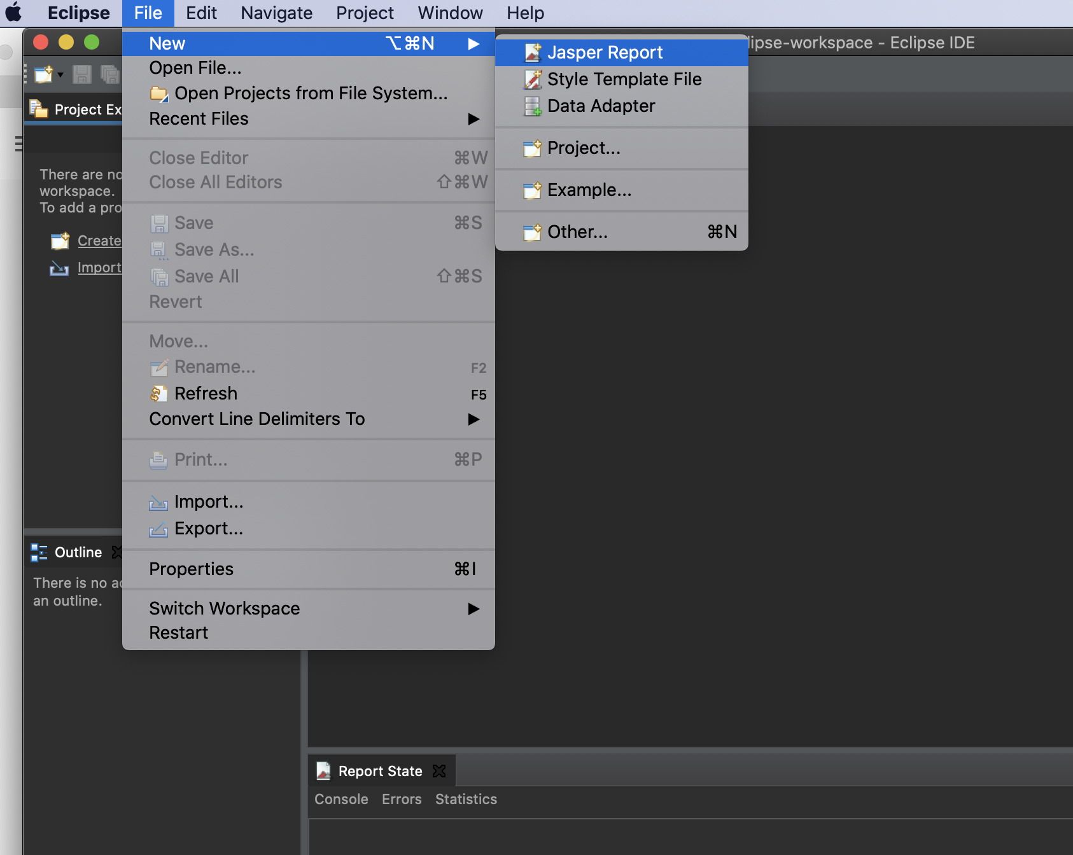

1. Choose a blank report template

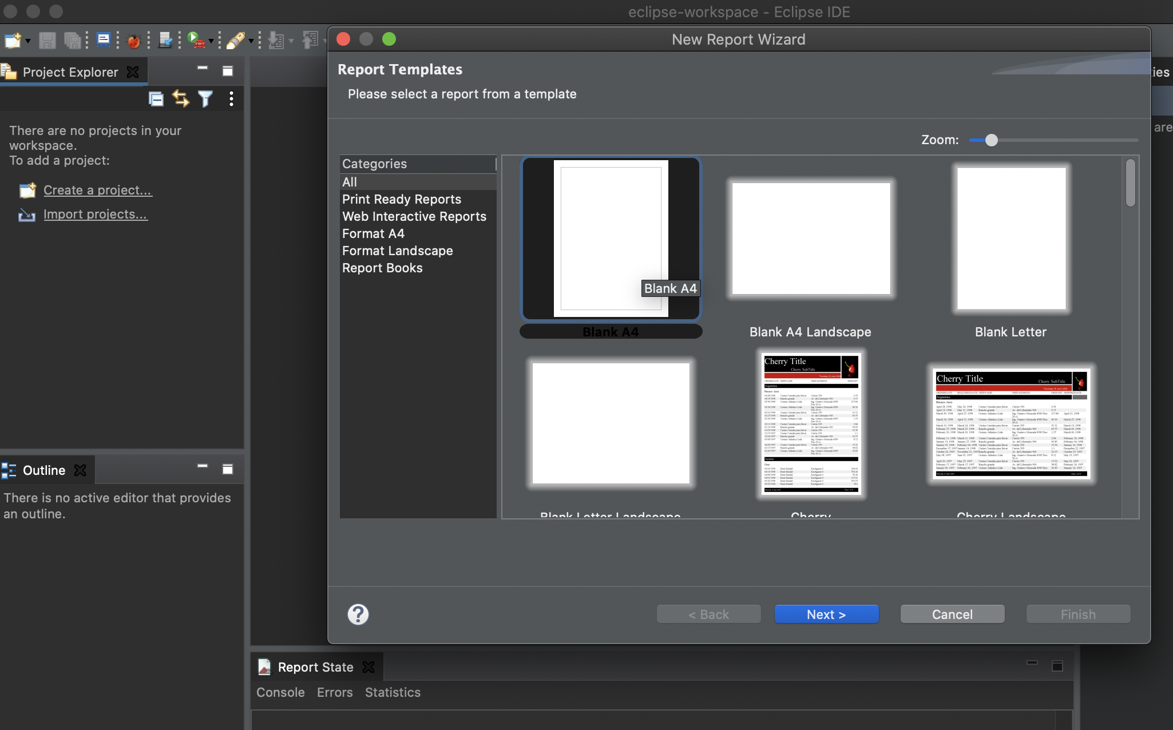

1. Provide a name for the jasper report

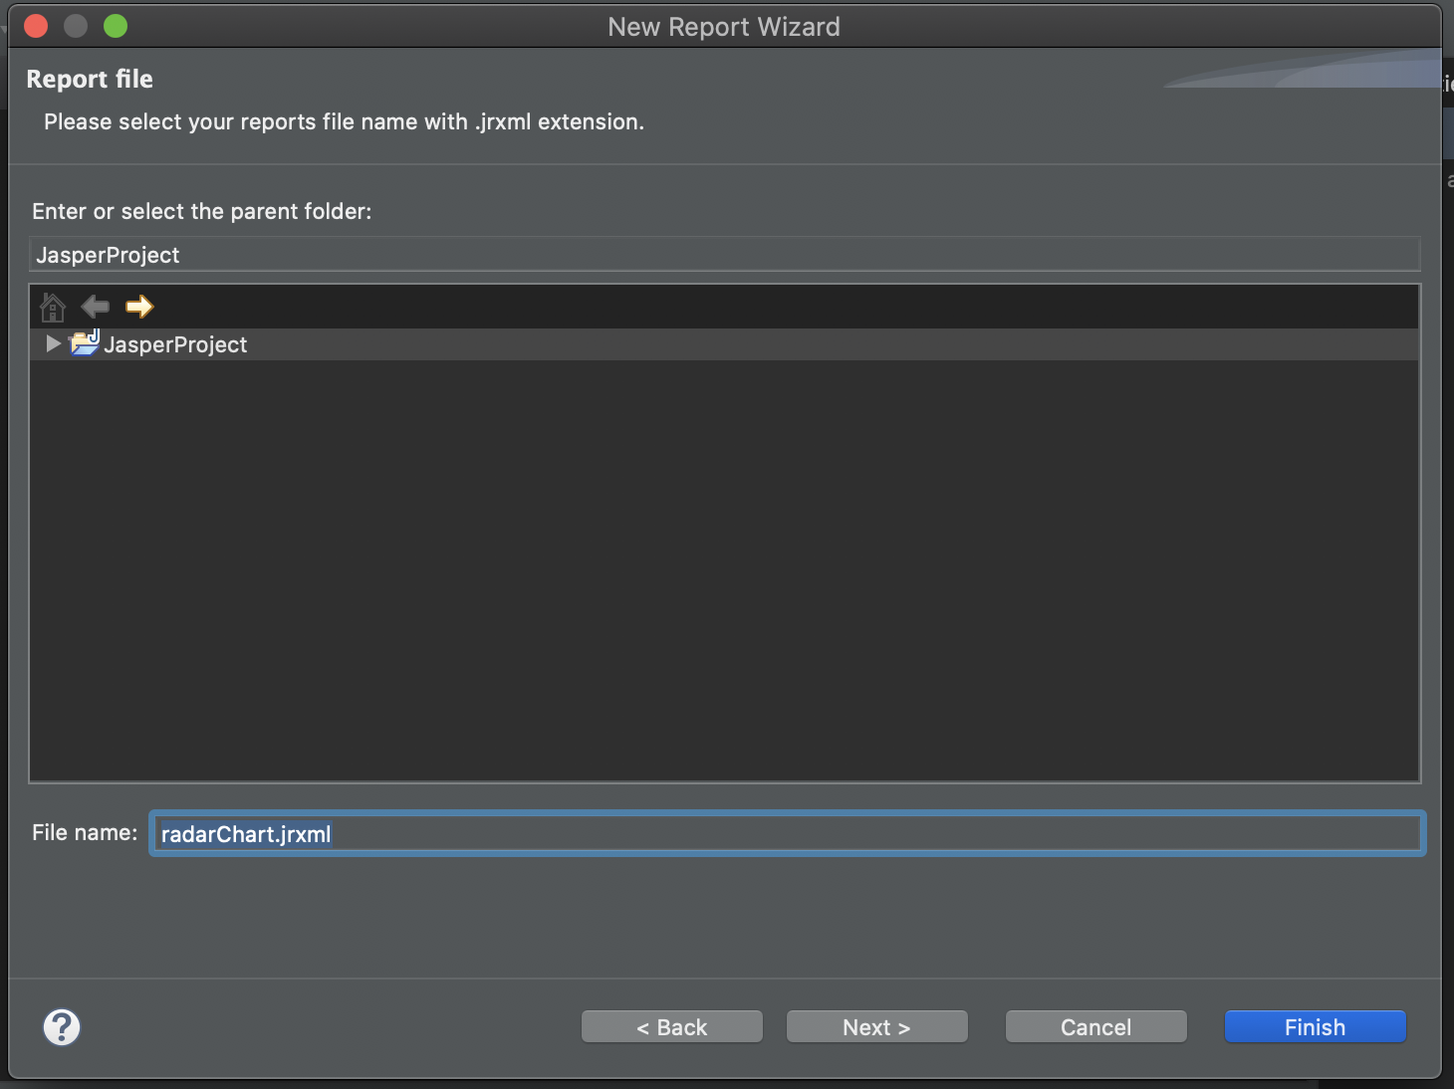

1. Select a database connection

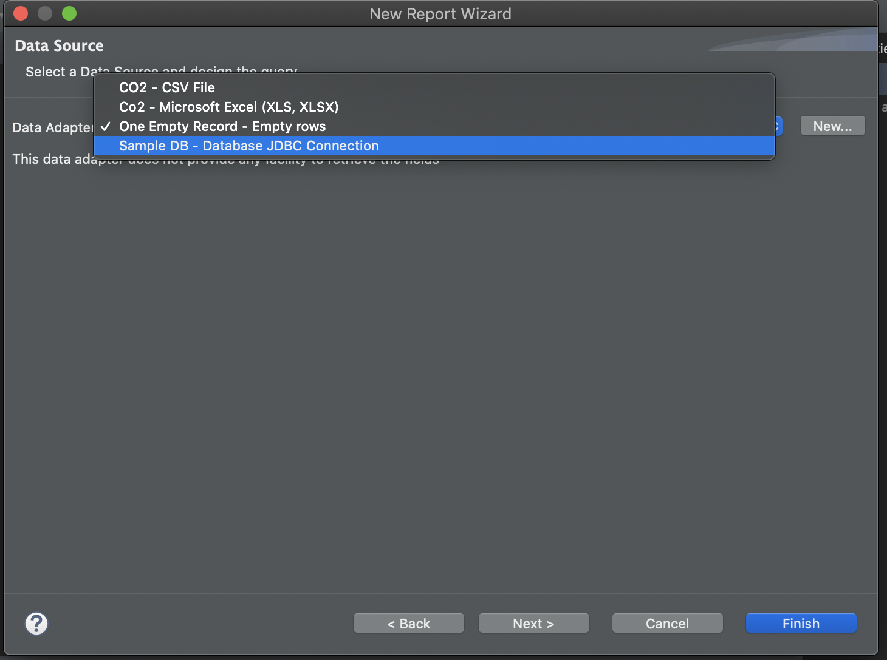

1. Create your SQL query to extract data required.

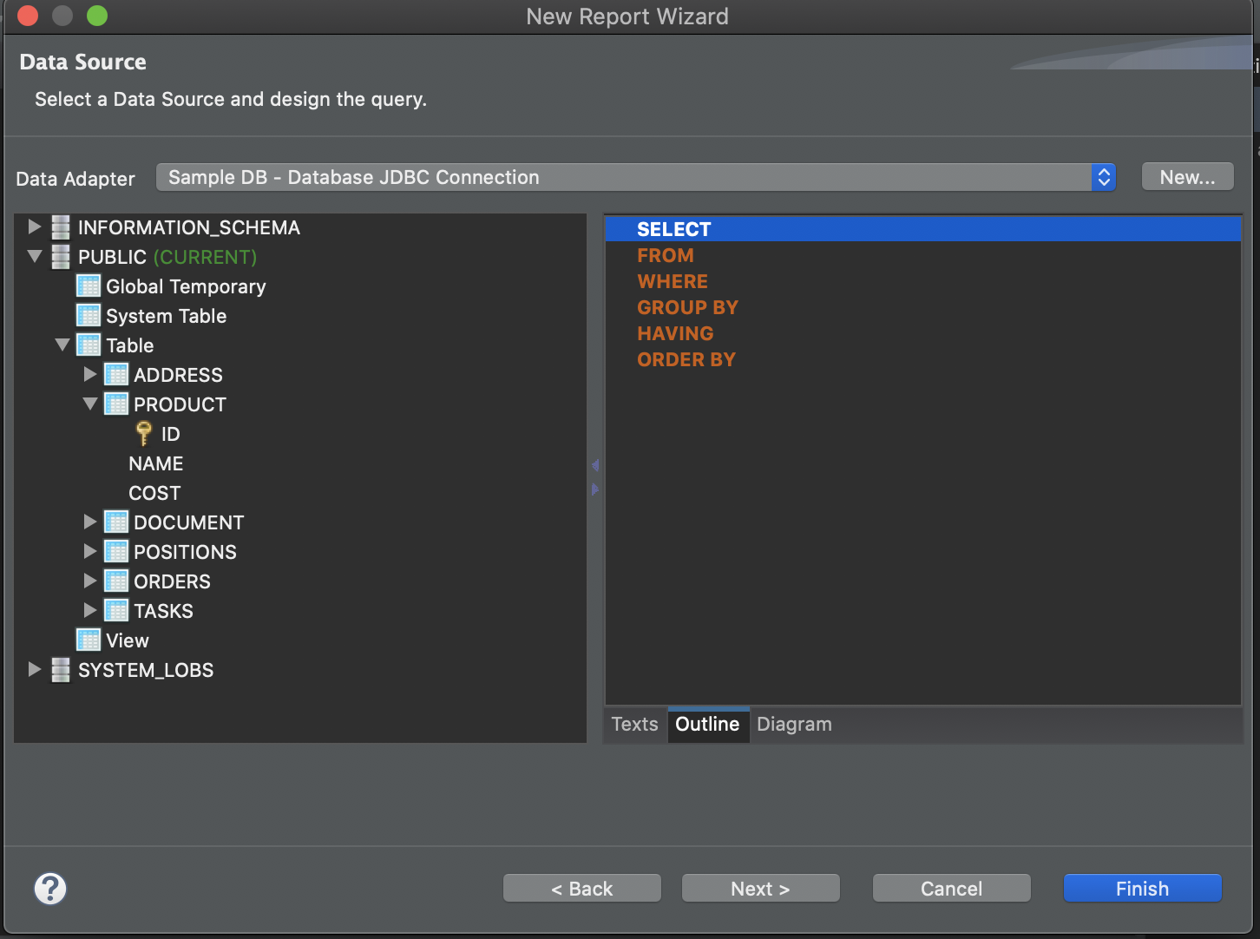

2nd data source option using excel file/csv as imported data

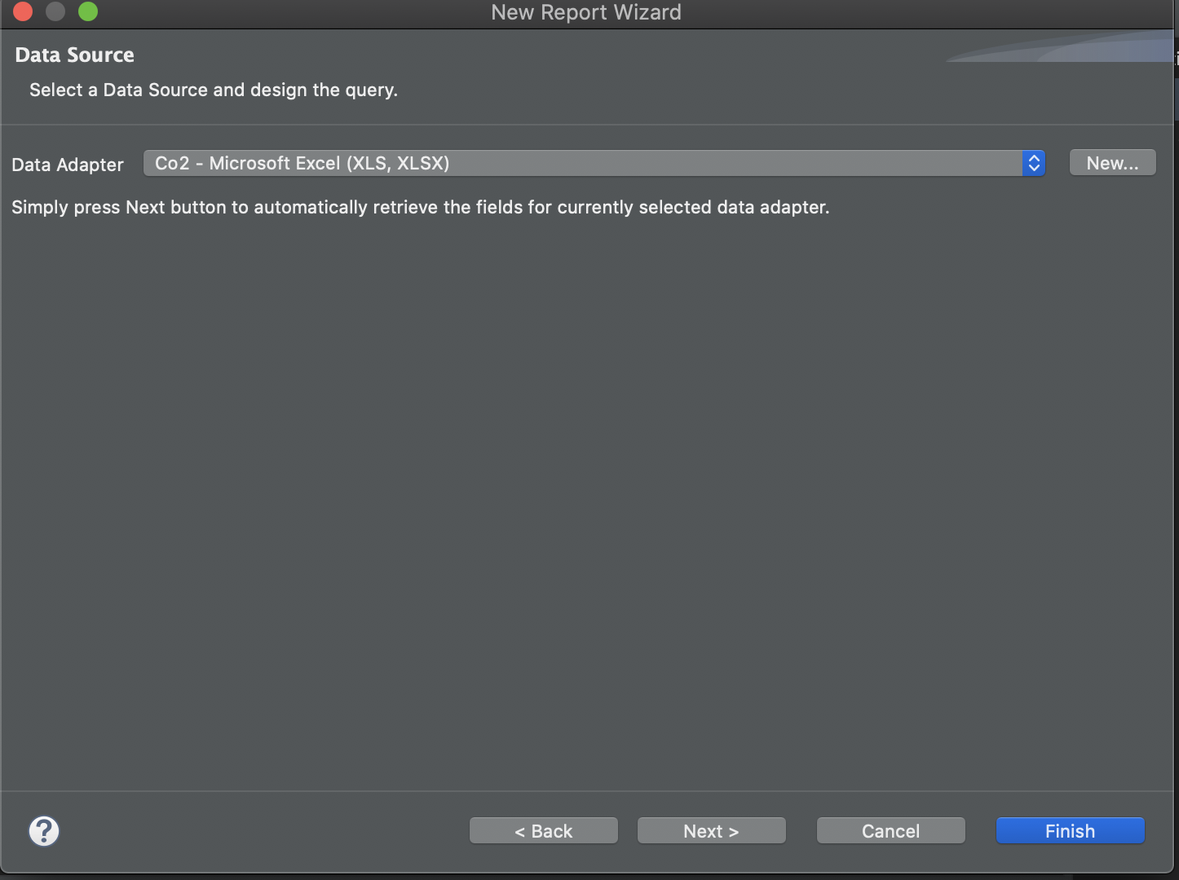

1. Copy data from left to right and select finish, this will now make data available to report against.

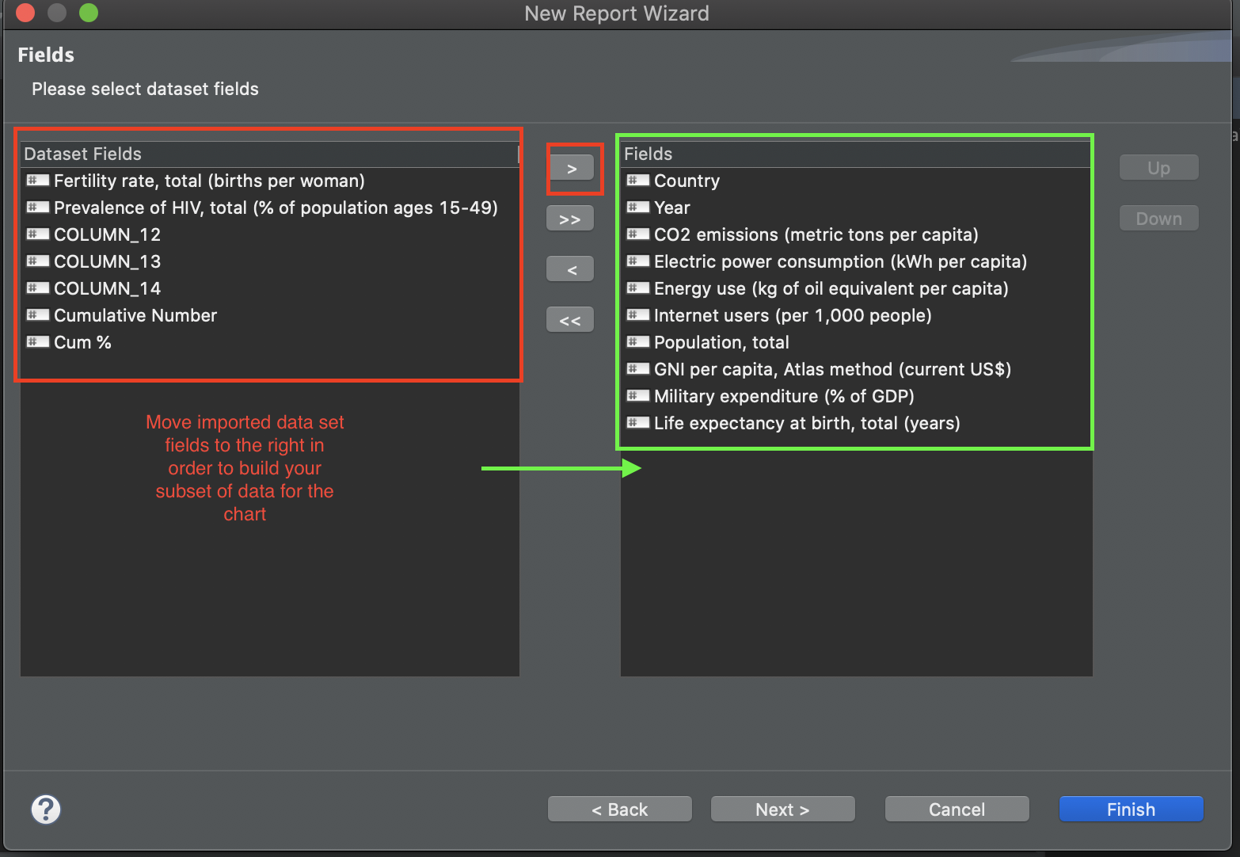

**Group By**

Groups allow you to organize the records of a report with a better structure. A group is defined through an expression, so it can contain fields and variables, JasperRepors evaluates this expression and puts in the same group all the elements that have the same final result of the expression. When the result change then a new group is started. To create a new group go into the Outline view, right click on the root element (the report you have created) and select "Create Group".